How to Prevent Windows Update from Updating Smartcard Reader Device Drivers in Windows 10

Published 20th Oct 2021

**Contents**

Purpose 3

Microsoft Default Driver Issue 3

How to Identify the Device Ids 4

Device Ids Table 6

Prevent Updating Drivers for a Particular Device 6

Configure Group Policy to prevent updating drivers for a particular device 6

Configure Registry to prevent updating drivers for a particular device 8

# Purpose

A recent Windows 10 update has introduced a new issue in the Smartcard self-renewal functionality. The reason is that the update is causing the Smartcard manufacturer’s drivers to be replaced by the Microsoft USBCCID Smartcard reader drivers.

We are working with Microsoft to try to stop this happening, but in the meantime there is an alternative way by which we can prevent Windows update from updating the specific drivers which are causing the problem.

# Microsoft Default Driver Issue

All newly built Windows 10 machines default to use the ***Microsoft Usbccid Smartcard Reader (WUDF)*** **Driver** irrespective of smartcard reader type. This is NOT the correct driver for any of the Smartcard readers used in the NHS and using it causes various authentication and smartcard operation issues including failures with self-renewal of Smartcards. It can also cause power management issues where the reader powers down during CMS operations.

The correct drivers need to be installed from the list below. Admin rights are needed to install the drivers. This information is also available at: <http://nww.hscic.gov.uk/dir/downloads/index.html#reader_drivers>

1. Omnikey 3121 USB Smartcard Reader marked ‘Made in Philippines’

<https://www.hidglobal.com/drivers/29765>

1. Omnikey 3121 USB Smartcard Reader marked ‘Assembled in Mexico’

<https://www.hidglobal.com/products/omnikey-nhs>

1. Omnikey 5121 Contactless Smartcard Reader

<http://www.hidglobal.com/drivers/29765>

1. Download the HP KUS-0133 Keyboard Reader

<http://h20564.www2.hp.com/hpsc/swd/public/detail?swItemId=ir_79253_1#tab2>

1. Users of Dell integrated keyboard smart card readers such as the RT7D60 and SK-3205 can use the following drivers to ensure full compatibility with NHS services – DellDrivers.zip [[RT7D60](http://nww.hscic.gov.uk/dir/downloads/Dell-Keyboard.zip) or [SK-3205](http://nww.hscic.gov.uk/dir/downloads/SK3205-REPACK.zip)]

Once the correct drivers for the reader are installed, then the steps in the rest of this document are required to prevent Windows update from replacing the correct drivers with the incorrect Microsoft driver again.

# How to Identify the Device Ids

1. Open Device Manager Properties window by typing *Device Manager*, in Windows search or by typing *devmgmt.msc* and hit the Enter key. This will open the Device Manager Properties Window  
   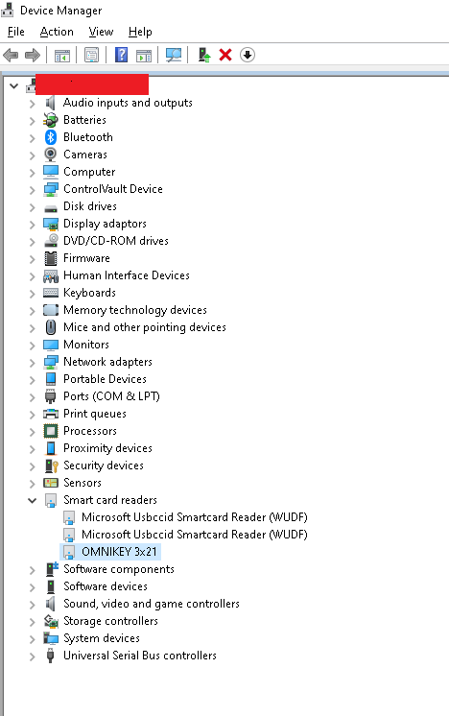
2. Go to Smart Card Readers and locate the device  
   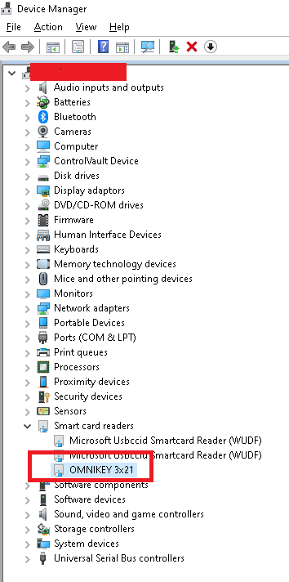
3. *Double Click* or *Right Click* and select *Properties* from the context menu.  
   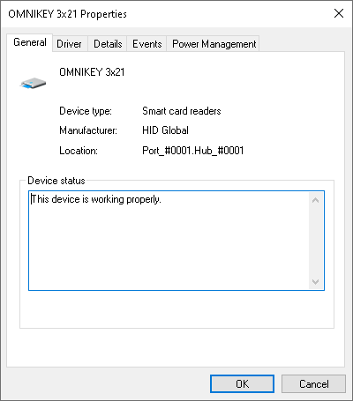
4. Switch to *Details* tab  
   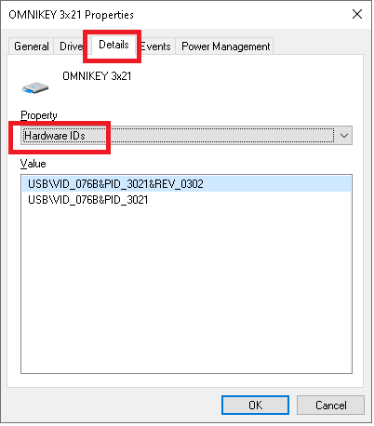
5. Right-click on the ID you want, and select Copy from the context menu to copy it.  
   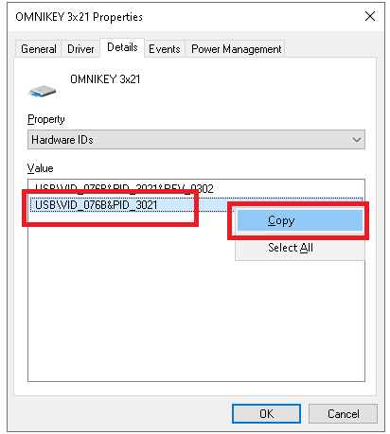  
     
   **Note:** For most devices there are more than one Hardware Ids. Usually the first two are the ones you need. The first one is the actual Hardware Id of your device and is specific to your device. For proper prevention, it is recommended to select the second one, which is more generic.

# Device Ids Table

|  |  |  |
| --- | --- | --- |
| **Smart Card Reader Name** | **Device Ids** | **Country of Origin** |
| Dell Keyboard | USB\VID_413C&PID_2101 |  |
| OmniKey | USB\VID_076B&PID_3031 | Mexico |
| OmniKey | USB\VID_076B&PID_3021 | Philippines |

**Note:** Before making the changes to the Group Policy or Register it’s better to verify the device id following the How to Identify the Device Ids

# Prevent Updating Drivers for a Particular Device

There are two ways to prevent updating device drivers which match any of the device ids

## Configure Group Policy to prevent updating drivers for a particular device

1. Open Group Policy editor, by typing *Edit group policy*, in Windows search or by typing *gpedit.msc*, and hit the *Enter* key. This will open *Group Policy Editor*.
2. Go to *Computer Configuration > Administrative Templates > System > Device Installation > Device Installation Restrictions.*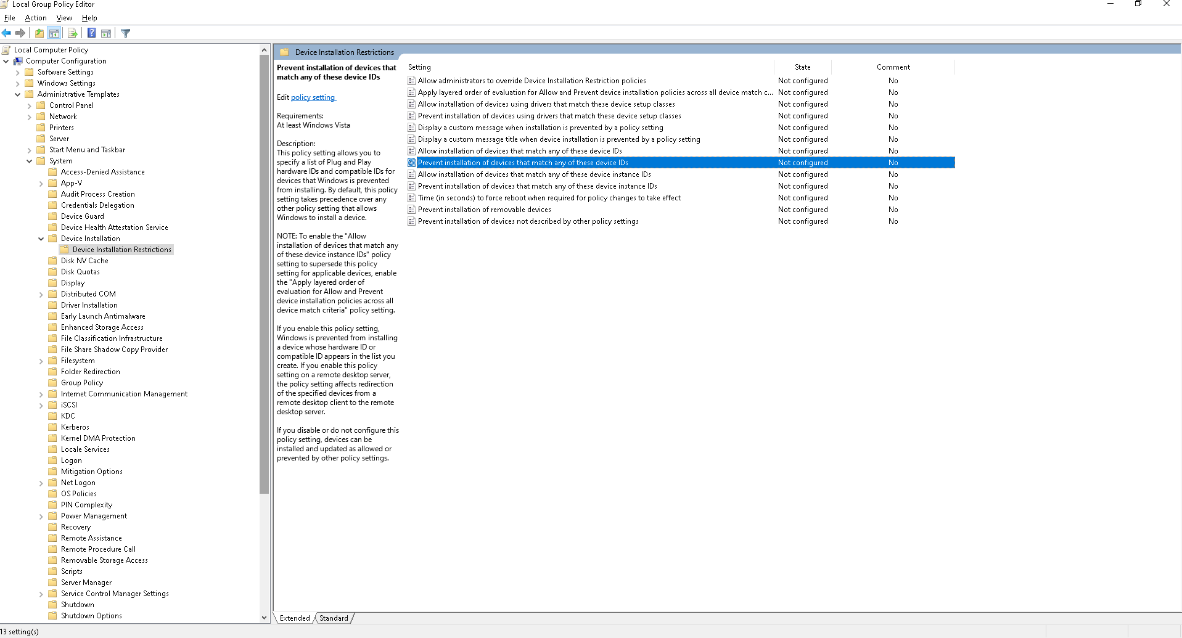
3. Double-click on *"Prevent installation of devices that match any of these device IDs"*. Change the *Status* to *Enabled*. You can also select the *"Also apply to matching devices that are already installed"*, which will prevent installation or update of already installed devices. That means that already installed devices that match the Hardware Id, will be retroactively uninstalled and not allowed to be installed for as long as the Policy is *Enabled* (active)!  
     
   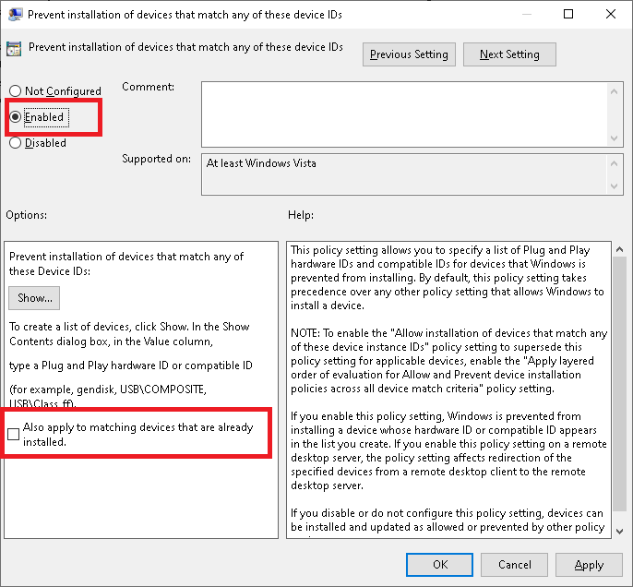
4. Click on the *Show* button and add the device ids  
   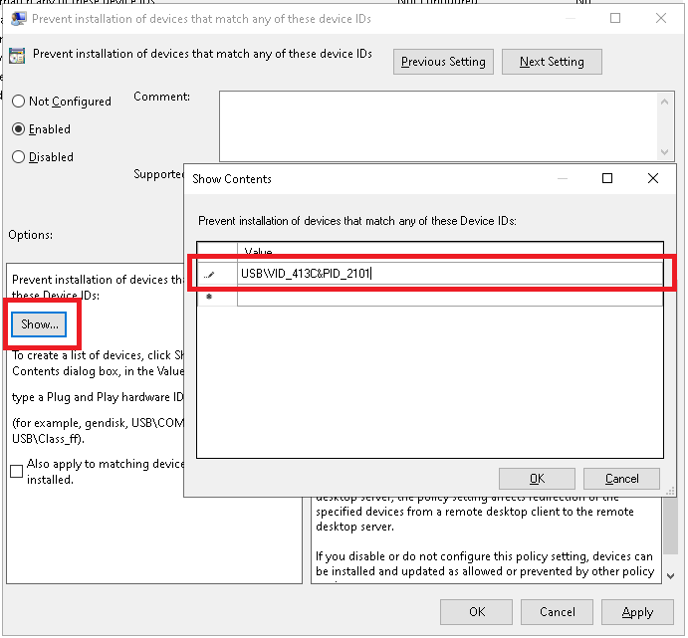  
   **Note:**   
   To identify the device id follow How to Identify the Device Ids or Device Ids Table  
     
   All device values (= Hardware Ids) entered in this section, will not be updated either by Windows Update or manually by the user. Note that one hardware ID, per device, is enough, you don't need to add all the Hardware Ids listed in Device Manager.

## Configure Registry to prevent updating drivers for a particular device

If not using Group policy, then the same can be achieved using the registry.

### Manual Changes

1. Open Registry editor, by typing *Registry Editor*, in Windows search or by typing *Regedit*, and hit the *Enter* key.   
   
2. Navigate to *HKEY_LOCAL_MACHINE\SOFTWARE\Policies\Microsoft\Windows*
3. Add or Navigate to *DeviceInstall* Key  
   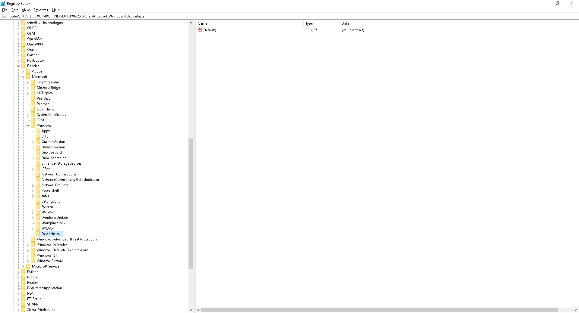
4. Add or Navigate to *Restrictions* Key  
   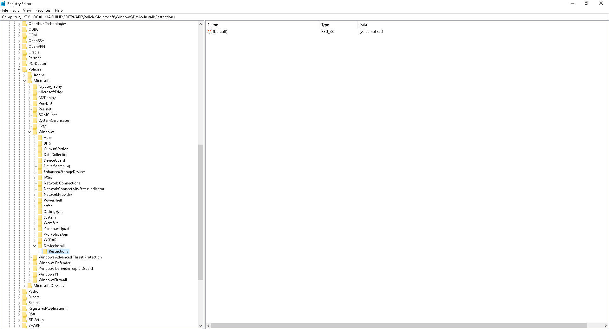
5. Ensure the selected key is *Computer\HKEY_LOCAL_MACHINE\SOFTWARE\Policies\Microsoft\Windows\DeviceInstall\Restrictions*
6. Add a new DWORD key at the following location *Computer\HKEY_LOCAL_MACHINE\SOFTWARE\Policies\Microsoft\Windows\DeviceInstall\Restrictions*  
   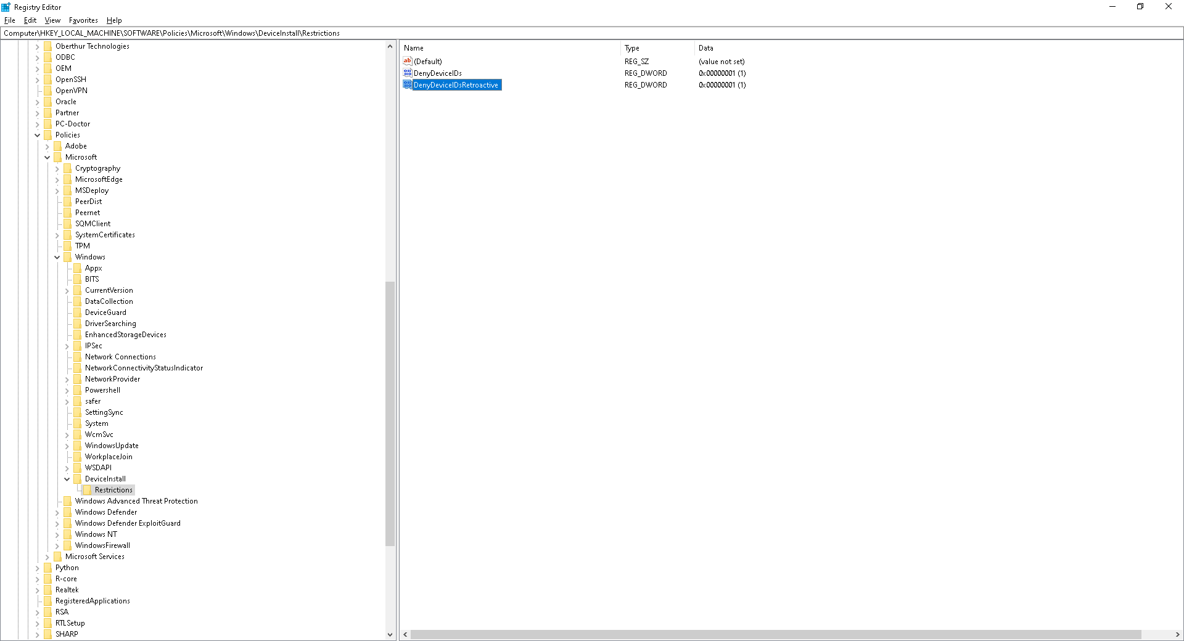

|  |  |  |
| --- | --- | --- |
| **Key Name** | **Value** | **Comments** |
| DenyDeviceIDs | 1 | Following values are supported 1 = Enable 2 = Disable |
| DenyDeviceIDsRetroactive | 1 | Corresponds to the *"Also apply to matching devices that are already installed"* checkbox: 1 for checked, 0 for not. |

1. Add or Navigate to *DenyDeviceIDs* Key  
   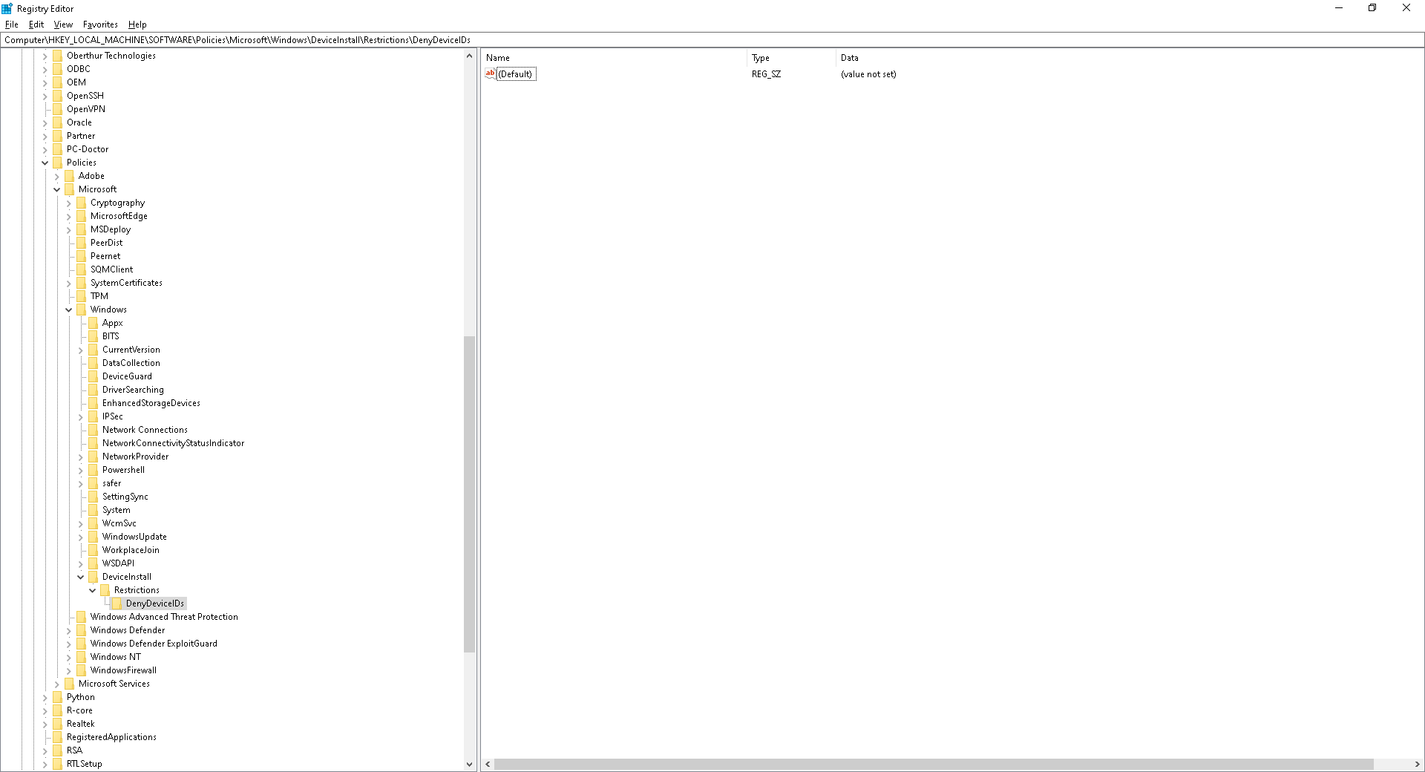
2. Add the STRING key value in the *Computer\HKEY_LOCAL_MACHINE\SOFTWARE\Policies\Microsoft\Windows\DeviceInstall\Restrictions\DenyDeviceIDs*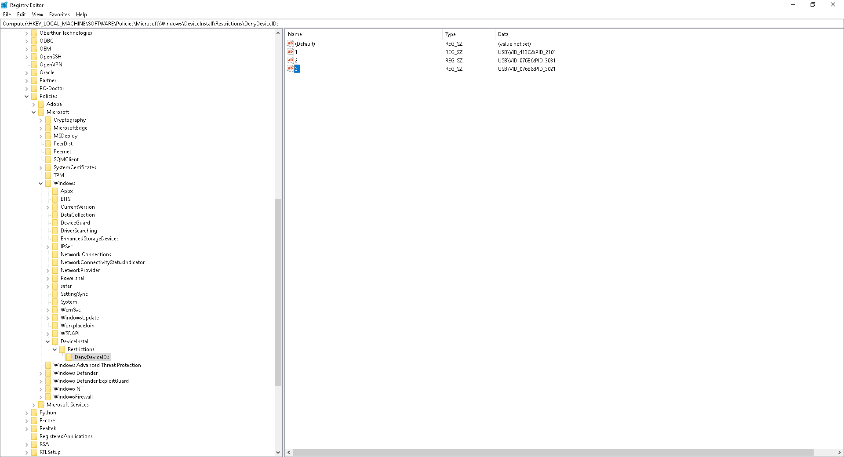

|  |  |  |
| --- | --- | --- |
| **Key Name** | **Value** | **Comments** |
| Any Value (sequence number) | Device Hardware Id | Key name can be the serial number |

**Note:**   
To identify the device id follow How to Identify the Device Ids or Device Ids Table

### Registry Script

Following script can be executed to add the device ids to prevent updating drivers for a particular drivers.

|  |
| --- |
| Windows Registry Editor Version 5.00  [HKEY_LOCAL_MACHINE\SOFTWARE\Policies\Microsoft\Windows\DeviceInstall]  [HKEY_LOCAL_MACHINE\SOFTWARE\Policies\Microsoft\Windows\DeviceInstall\Restrictions]  "DenyDeviceIDs"=dword:00000001  "DenyDeviceIDsRetroactive"=dword:00000000  [HKEY_LOCAL_MACHINE\SOFTWARE\Policies\Microsoft\Windows\DeviceInstall\Restrictions\DenyDeviceIDs]  "1"="<Device Hardware Id>"  "2"="<Device Hardware Id>"  "3"="<Device Hardware Id>" |

**Note:** Replace the <Device Hardware Id> with the device ids follow How to Identify the Device Ids or Device Ids Table

Copyright © 2020 Health and Social Care Information Centre. All rights reserved.

This work remains the sole and exclusive property of the Health and Social Care Information Centre and may only be reproduced where there is explicit reference to the ownership of the Health and Social Care Information Centre.

This work may be re-used by NHS and government organisations without permission.

**Published by the Health and Social Care Information Centre**

For further information, feedback, and questions please visit:

<https://www.networks.nhs.uk/nhs-networks/identity-agent>

or sign up to our Slack channel:

[https://identityagent.slack.com](https://identityagent.slack.com/)